**School Safety**

**Drill Record**

**2024-2025**

|  |  |  |  |
| --- | --- | --- | --- |
| School Name: Burr Elementary |  | | |
| **Fire Drills**  (reasonably spaced; 3 of the 5 must be held by Dec. 1st) | | | |
| Conducted by: Christian Mueller | | Date: 9/12/2024 | Time:10 am |
| Conducted by: Christian Mueller | | Date: 9/26/2024 | Time: 2pm |
| Conducted by: Christian Mueller | | Date:10/17/2024 | Time:11 am |
| Conducted by: Christian Mueller | | Date: | Time: |
| Conducted by: Christian Mueller | | Date: | Time: |
| **Tornado Safety Drill**  (one shall occur in March) | | | |
| Conducted by: Christian Mueller | | Date: 10/1/2024 | Time: 9:30 |
| Conducted by: Christian Mueller | | Date: | Time: |
| **Lock Down or Shelter-in-Place Drill**  (reasonably spaced; at least 1 before Dec. 1st and 1 after Jan. 1st) | | | |
| Conducted by: Christian Mueller | | Date:/11/20/2024 | Time:11 am |
| Conducted by: Christian Mueller | | Date:/2/25/2025 | Time:2 pm |
| Conducted by: Christian Mueller | | Date: | Time: |

**NOTE:** one of the 10 drills listed above must occur during a lunch, recess or other period when a significant number of students are gathered but not in the classroom.

Christian Mueller

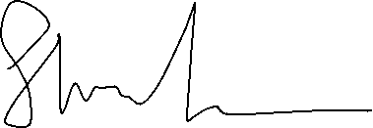

|  |  |
| --- | --- |
|  |  |
| Principal’s Signature | Printed Name |